|  |
| --- |
| **Health and safety arrangements - Part 2b:**  **site-specific risks & prevention measures – site KOR** |

|  |  |  |  |
| --- | --- | --- | --- |
|  | Created by | Checked by | Approved by |
| **Name** | Christophe Vermaete | Bruno Demey | Ronny Smismans |
| **Date** |  |  |  |
| **Position** | EHS Officer | EHS Officer | Director Facilities Management & EHS |

|  |  |  |  |
| --- | --- | --- | --- |
| Version | Author | Date | Description |
| AA | CHRIV |  | New document |
| AB | PEGCL | 19/10/2016 | Revision due to One Campus and actual evacuation instructions |
|  |  |  |  |
|  |  |  |  |
|  |  |  |  |

**Contents**

1 Purpose 3

2 Field of application 3

3 Definitions and abbreviations used 3

4 Associated documents 3

5 Responsibilities for the exchange of information 3

6 Safety, Health and Environment Plan 4

6.1 Loading and unloading 4

6.2 First-aid post 4

6.3 Evacuation plans 5

6.4 Specific health risks 6

6.4.1 Danger of electrocution 6

6.4.2 Mercury vapour lamp explosions 6

6.4.3 Artificial optical radiation 6

6.4.4 Laser light 6

6.4.5 Asbestos 6

6.4.6 Ionising radiation 7

6.4.7 Explosive areas, see 7

6.4.8 Confined spaces, see 7

6.4.9 Setting up cranes 7

6.5 Smoking areas 8

6.6 Specific rules 10

6.6.1 ESD (electrostatic discharge) areas 10

6.6.2 Clean rooms 10

6.6.3 Security 10

7 Agreement between the Instructing Party and the third-party contractor on these health and safety arrangements 11

# Purpose

Barco NV places great importance on health and safety in the workplace. In particular, Barco wants to guarantee workers’ health and safety during works involving third parties.

This document **supplements** 'Health and safety arrangements part 1: General regulations for all (BE) sites and all works involving third parties', and is specific for all works at the **site** **KOR** (Beneluxpark 21, Kortrijk).  
This Safety, Health and Environment Plan brings together all the **specific arrangements and risks** for the site KOR.

Please read this document carefully and discuss it with those of your employees who will be performing the works. Any comments or suggestions can be sent to our Internal Occupational Health & Safety Department.

**The exchange of information about, among others, mutual risks and the establishment of arrangements for suitable prevention measures are crucial to ensuring that the ideal cooperation between Barco NV and you, as the third-party contractor, can be achieved, and the works can be performed safely at all times.**

These **health and safety arrangements** form an integral part of the order form.

The requirements specified below form part of the terms & conditions of procurement.

Failure to comply with these requirements may result in the unilateral termination of the contract.  
Anyone who fails to comply with these arrangements may be refused access to Barco NV.

# Field of application

This document only applies to works involving third parties on the site KOR, Beneluxpark 21, Kortrijk.

# Definitions and abbreviations used

All definitions and abbreviations used are explained in part 1 of the health and safety arrangements (see EHS-PR-2032).

BLEVE = Boiling liquor expanding vapour explosion

# Associated documents

See EHS-PR-2032.

# Responsibilities for the exchange of information

Cooperation with external companies (including self-employed workers) is governed by the provisions of the Act on Welfare in the Workplace of 4 August 1996 (Arts 8 to 12).

The responsibilities and obligations with regard to the exchange of information are set out in Chapter 7 of part 1 of the health and safety arrangements (see EHS-PR-2032).

# Safety, Health and Environment Plan

## Loading and unloading

Loading and unloading may only be undertaken at the goods intake desk of the warehouse behind the KND 2 building.

## First-aid post

The first-aid post is, by definition, locked. If you need urgent help, the first person to call in all cases is the occupational first aider on duty, using the internal emergency number **66**.

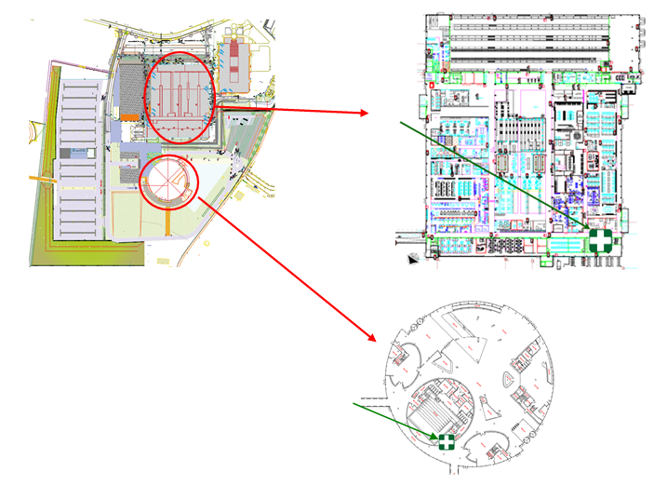

## Evacuation plans

Following evacuation, you must assemble on the car park in the zone that corresponds to the building where you were at that moment.

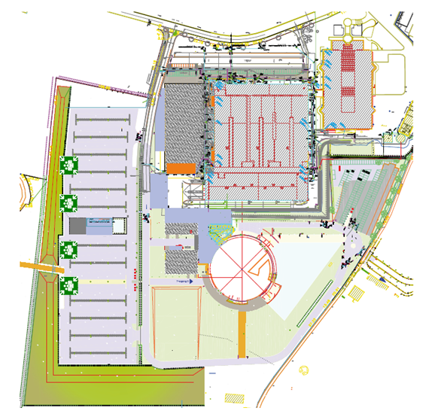

## Specific health risks

At various locations within our company there are risks which are inherent to the nature of our operations.



### Danger of electrocution

Areas involving danger of electrocution are signposted using the pictogram above. This chiefly relates to high-voltage cabinets, transformer rooms and low-voltage panels, but also covers overhead and underground power lines. Ask for information from the Facilities Management Coordinator or Installations Manager.

### Mercury vapour lamp explosions



Many of the lights used in our manufacturing process contain mercury.

If these lights fail when they are hot, mercury vapour may be released into the atmosphere. . Please follow the instructions given by the Barco representative in applying the emergency procedure in the event of this kind of incident.

Pregnant persons must not be exposed to these vapours: in any event, pregnant persons must immediately leave the danger zone.

### Artificial optical radiation



Our projectors typically have a very bright light source involving the risk of blinding. In some areas, it is also compulsory to wear special protective goggles. Before the works commence, please ask the Instructing Party what type of eye protection is required in these areas. Never look directly into a light source as this may cause lasting eye trauma.

### Laser light



In some areas, products incorporating laser technology are used.  
Specific training must be taken to be admitted to these areas. Wearing special laser safety goggles is compulsory in these areas. Before the works commence, please ask the Instructing Party what type of eye protection is required in these areas. **Exposure to laser light may cause permanent eye trauma.**

### Asbestos



There is no asbestos in these buildings.

### Ionising radiation

There is no ionising radiation in these buildings.

### Explosive areas, see



Explosive areas are indicated on site with the above pictogram

Ask for information from the Facilities Management Coordinator.

### Confined spaces, see



Confined areas may be accessed only with a valid works permit and subject to the necessary prevention measures being put in place.

Ask for information from the Facilities Management Coordinator.

### Setting up cranes

Because of the limited load-bearing capacity of the ground, four locations have been reinforced with a view to setting up telescopic and tower cranes, see indication K on the map. Telescopic and tower cranes may be set up only in these areas, following consultation with the Facilities Management Coordinator, in consideration of the load-bearing capacity.

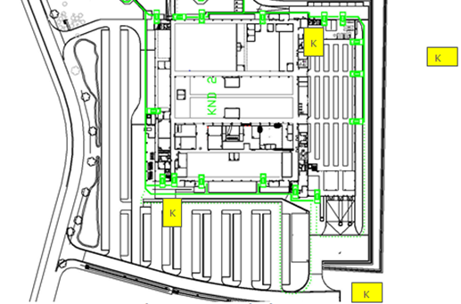

## Smoking areas

In principle, smoking is prohibited (both inside the buildings and on the grounds).  
Smoking is permitted only in the designated smoking areas.

Covered smokers area  
Smokers area without a roof

KND SMOKERS AREAS

## Specific rules

### ESD (electrostatic discharge) areas

Specific measures apply in the manufacturing areas to prevent damage to materials and equipment as a result of electrostatic discharges. An ESD dust coat and ESD safety shoes must be worn to enter these areas.



Touching or moving devices, printed circuit boards and other materials which are sensitive to electrostatic discharges is prohibited.

### Clean rooms

There are various clean rooms in the manufacturing zone. Entering these clean rooms or performing works in or to these clean rooms is permitted only with the consent of the manager of the clean room concerned and in compliance with the specific clean room regulations.

### Security

#### Known consigner accreditation

Specific security regulations apply in certain areas. For instance, part of the warehouse is accessible only to persons with a 'known consigner' accreditation. All other persons must be escorted in these areas by a Barco employee with the requisite accreditations.  
Please contact our Security Officer to check the requirements.

#### ITAR (International Traffic in Arms Regulations) areas

Some manufacturing areas are only accessible to employees of a specific nationality. If any of your employees who come to Barco to work do not have Belgian nationality, or if one and the same person has various nationalities, they must report to reception and ask to put this information to the Security Officer, who will assess the conditions under which they may be granted access to these areas.

# Agreement between the Instructing Party and the third-party contractor on these health and safety arrangements

This agreement forms an integral part of the contract with the third-party contractor.

The parties may terminate the agreement if either of them fails to comply with its obligations under the contract.

By their signatures, the Instructing Party and the third-party contractor confirm their mutual agreement to the health and safety arrangements, including all annexes and checklists appended thereto.

By its signature, the third-party contractor confirms having received the health and safety arrangements entitled "Works involving third parties" and that it shall comply with all the provisions contained therein as well as with all statutory provisions on workplace welfare.

By its signature, the third-party contractor hereby also declares that all data provided are accurate and complete.

|  |  |
| --- | --- |
| Representative for the Instructing Party, | Representative for the third-party contractor, |
| Name: | Name: |
| Signature: | Signature: |
| Date: | Date: |

Done at ...................................... on ................................. 20...... in duplicate, with each party acknowledging receipt of an original copy.